Name: Nooreldeen Ayman Mohammed Elmobashar
Track: Open Source
Branch: ITI Mansoura
____________________________________________

1. Compress a file by compress, gzip, zip commands and decompress it again. State the
differences between compress and gzip commands.

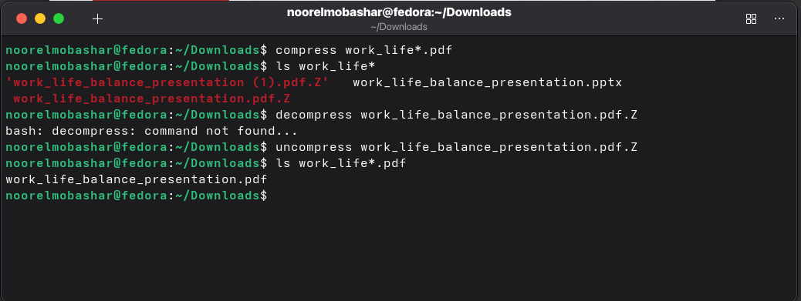
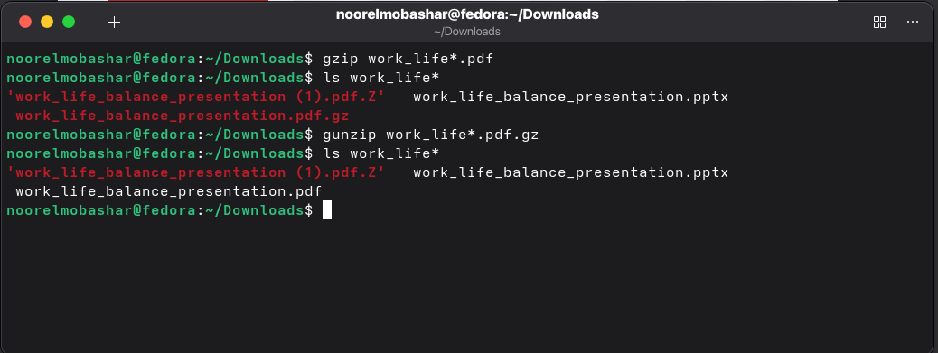
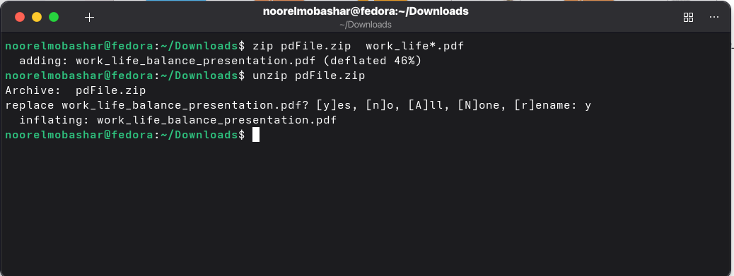
compress uses old LZW algorithm and gzip uses more efficient DEFLATE algorithm LZ77

gzip has a high compression ration than compression

2. What is the command used to view the content of a compressed file.

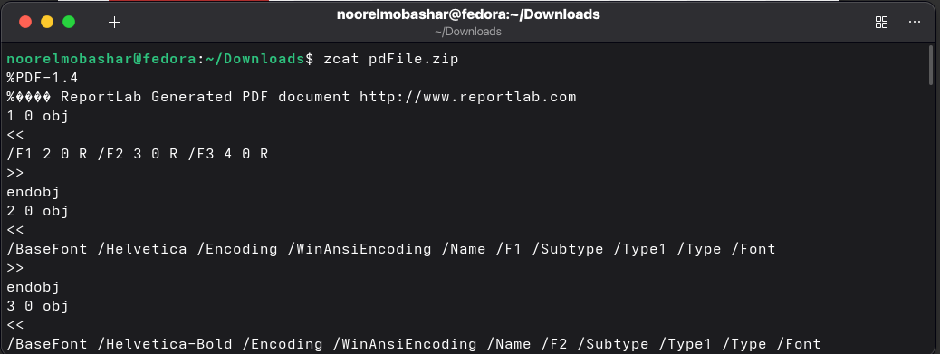

3. Backup /etc directory using tar utility.

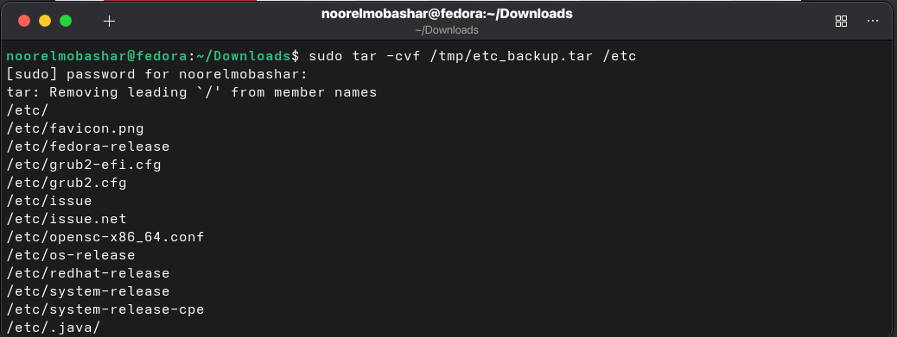
4. Starting from your home directory, find all files that were modified in the last two day.

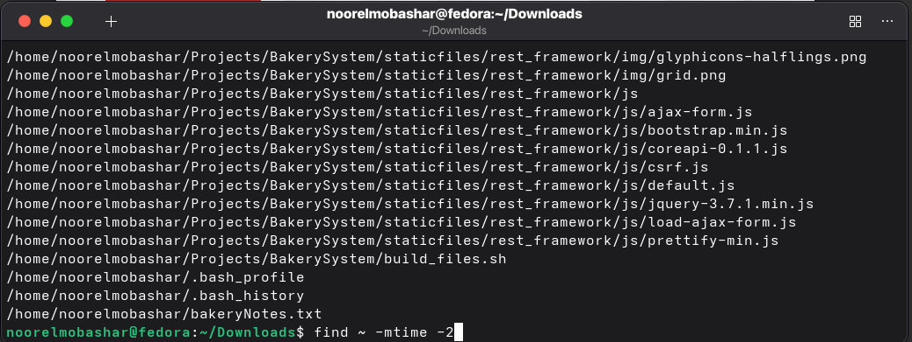

5. Starting from /etc, find files owned by root user.
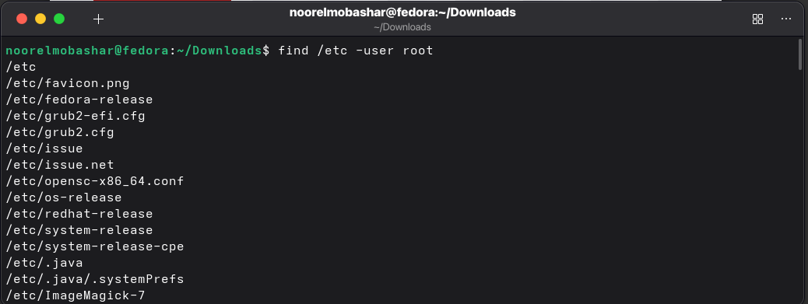
6. Find all directories in your home directory.

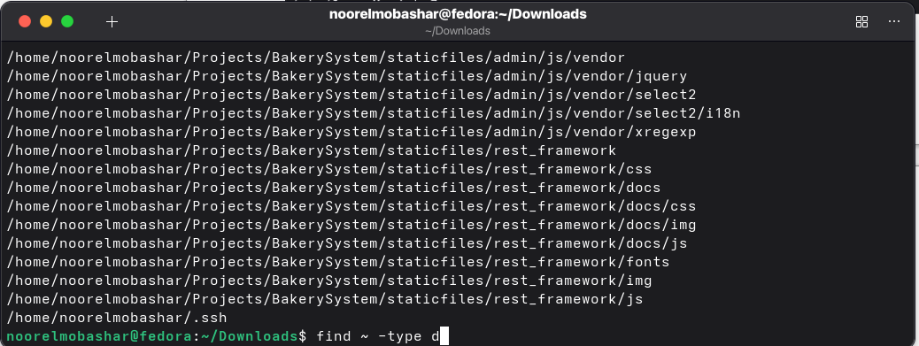

7. Write a command to search for all files on the system that, its name is “.profile”.

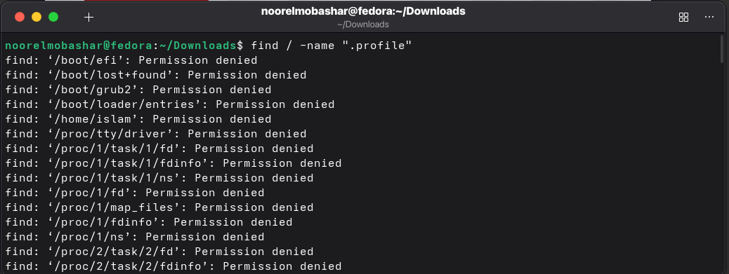

8. Identify the file types of the following: /etc/passwd, /dev/pts/0, /etc, /dev/sda

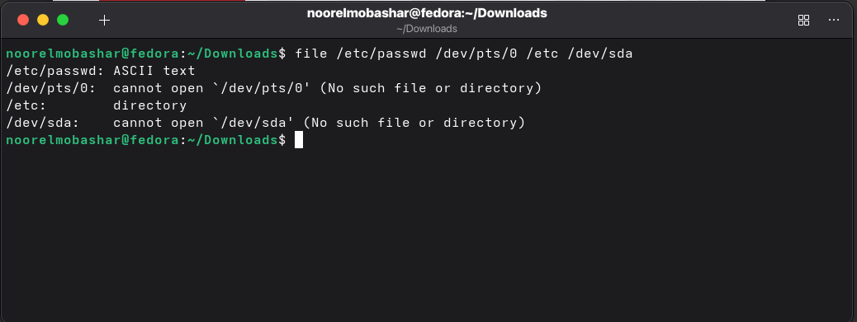
9. List the inode numbers of /, /etc, /etc/hosts.

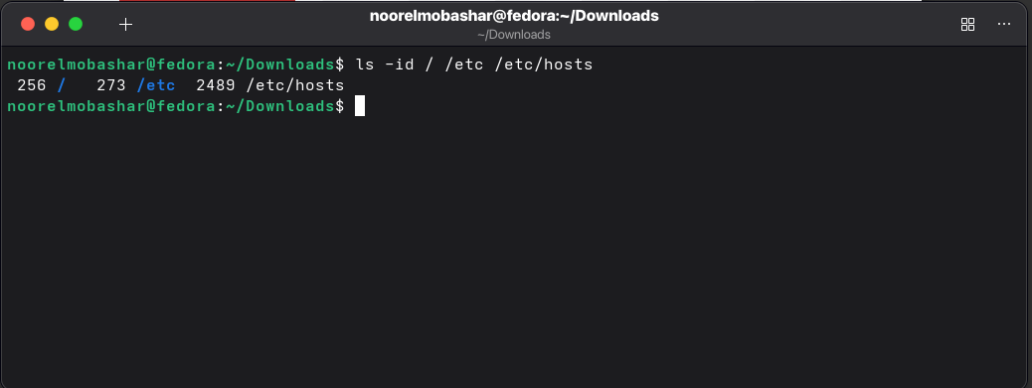

10. Copy /etc/passwd to your home directory, use the commands diff and cmp, and Edit in the
file you copied, and then use these commands again, and check the output.

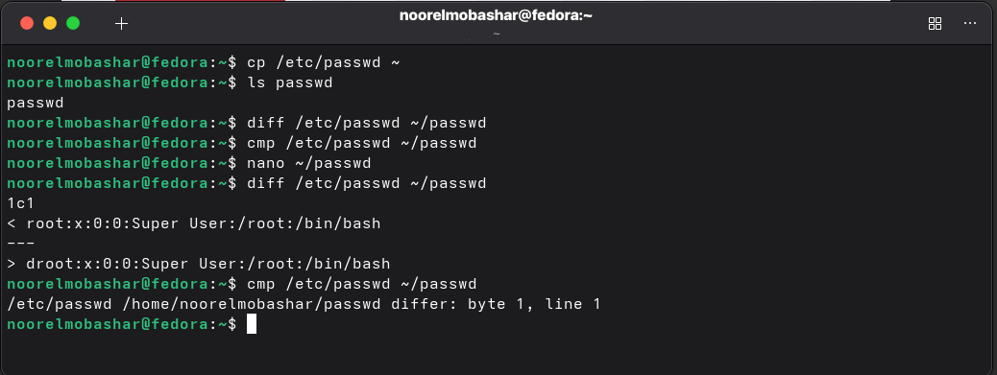
11. Create a symbolic link of /etc/passwd in /boot.

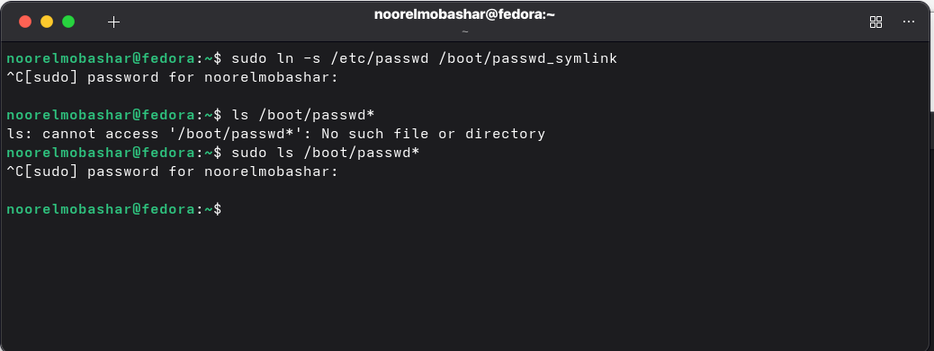
12. Create a hard link of /etc/passwd in /boot. Could you? Why?

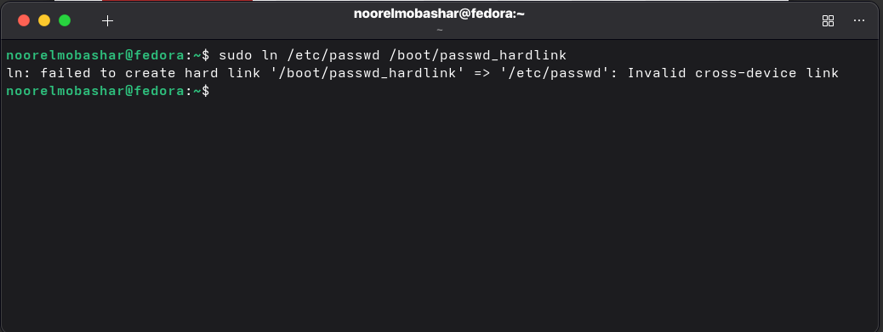
I can’t, because hard links cannot span across different filesystems, as /boot is a different partition than /root

